**Azure – Query result Assignment**

**Database Name:** Chinook

The Chinook Database is migrated to Microsoft Azure SQL database using SQL server 2016. Each table’s row count is displayed below.

**Record Count:**

select distinct t.name as 'Table Name' ,s.row_count as 'Row Counts' from sys.tables t join sys.dm_db_partition_stats s ON t.object_id = s.object_id and t.type_desc = 'USER_TABLE'

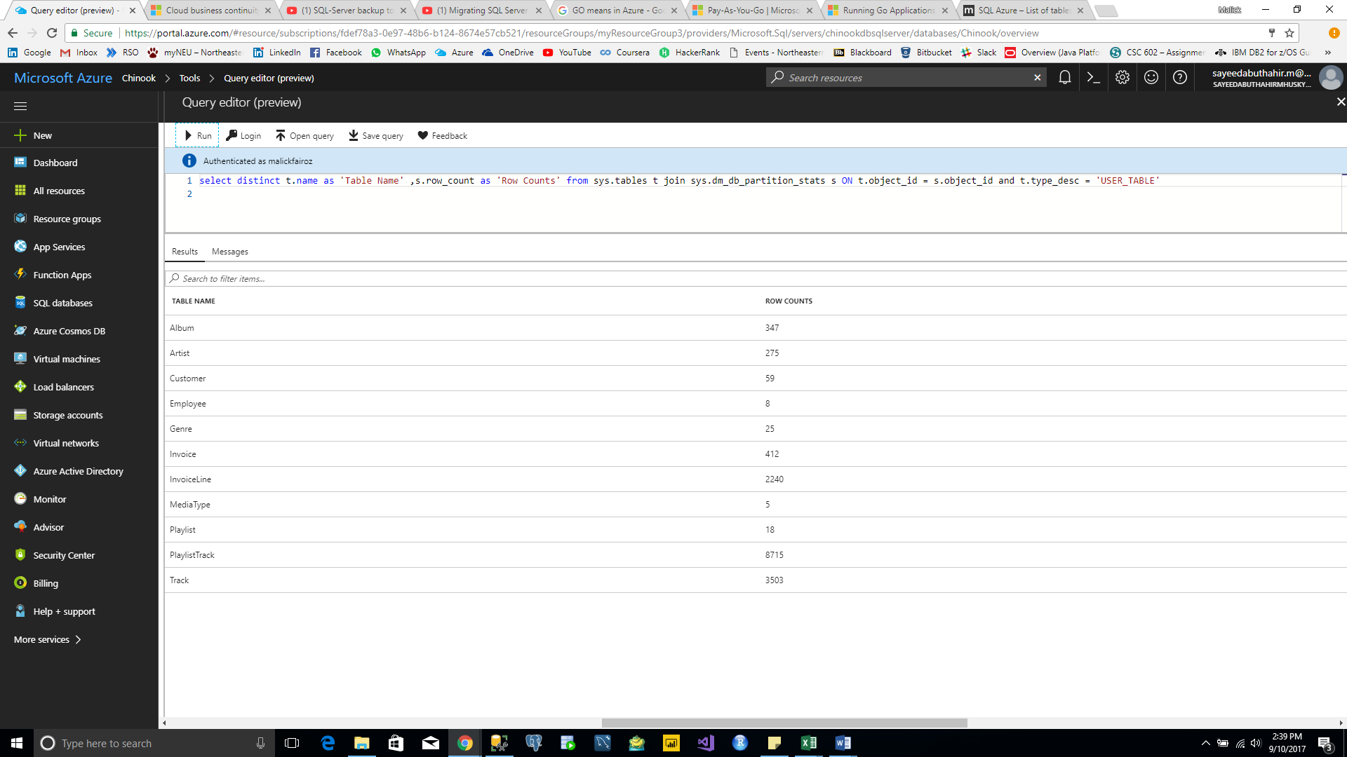

**Query 1:**

select sum(Total) as TotalSales from chinook.dbo.Invoice;

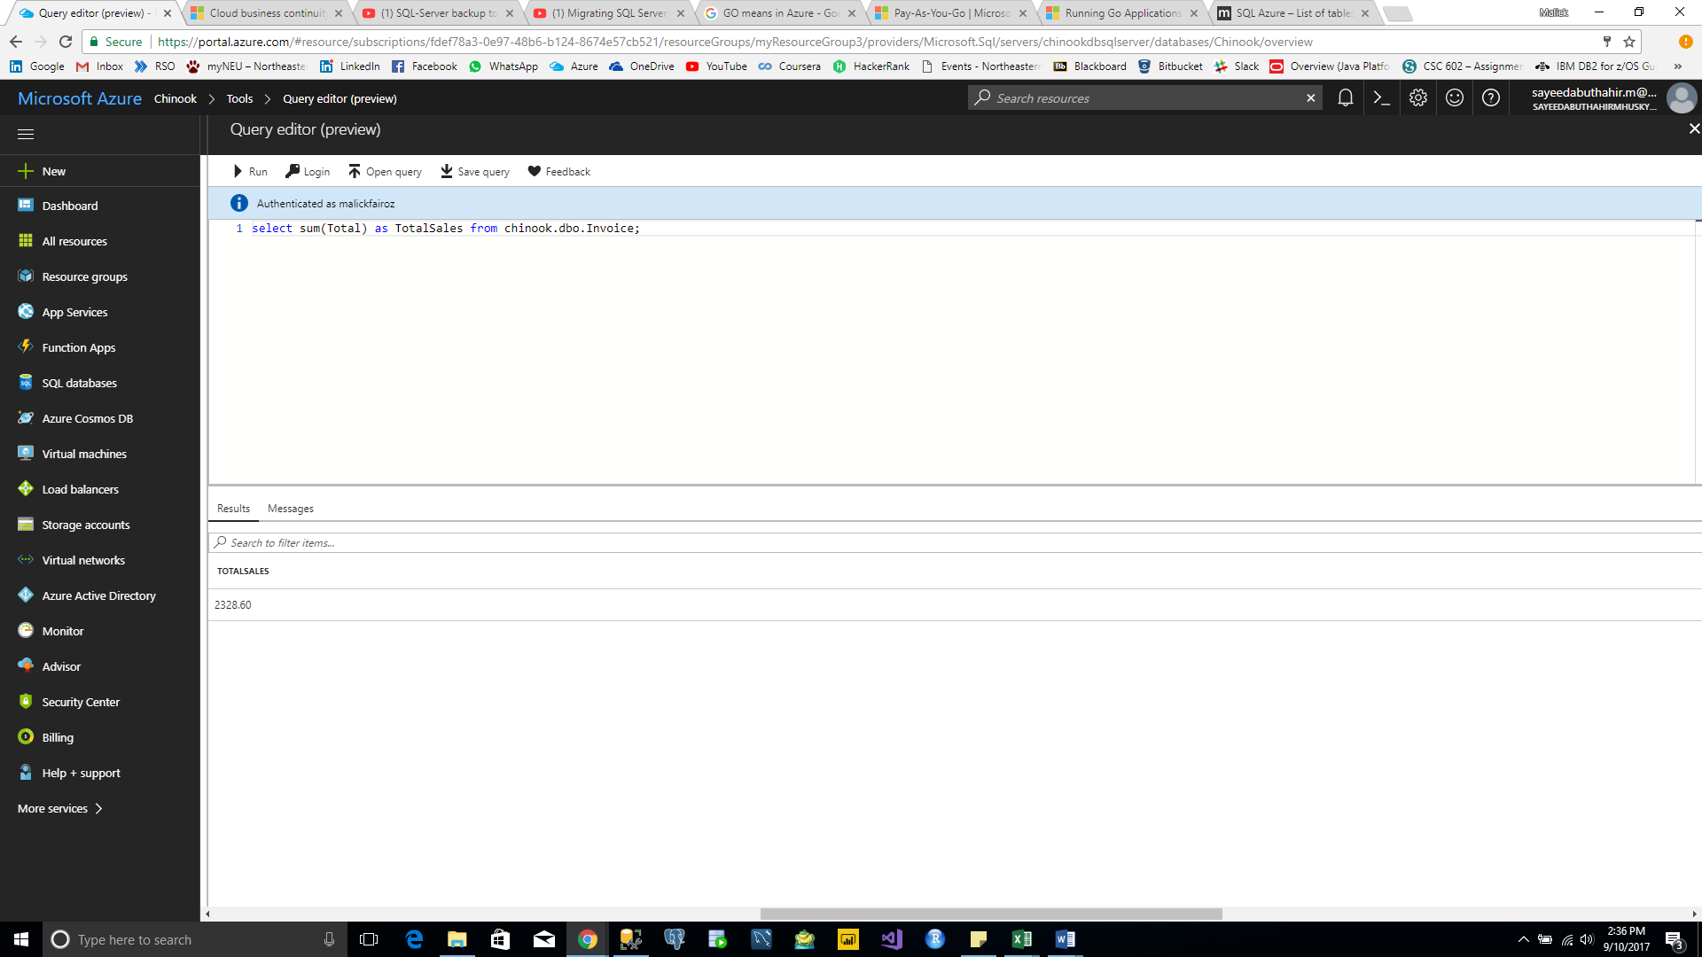

**Query 2:**

select billingcountry as CountryName, sum(Total) as TotalSales, Dense_Rank() over(order by sum(total) desc) as CountryRank from chinook.dbo.Invoice

group by billingcountry order by sum(Total) desc;

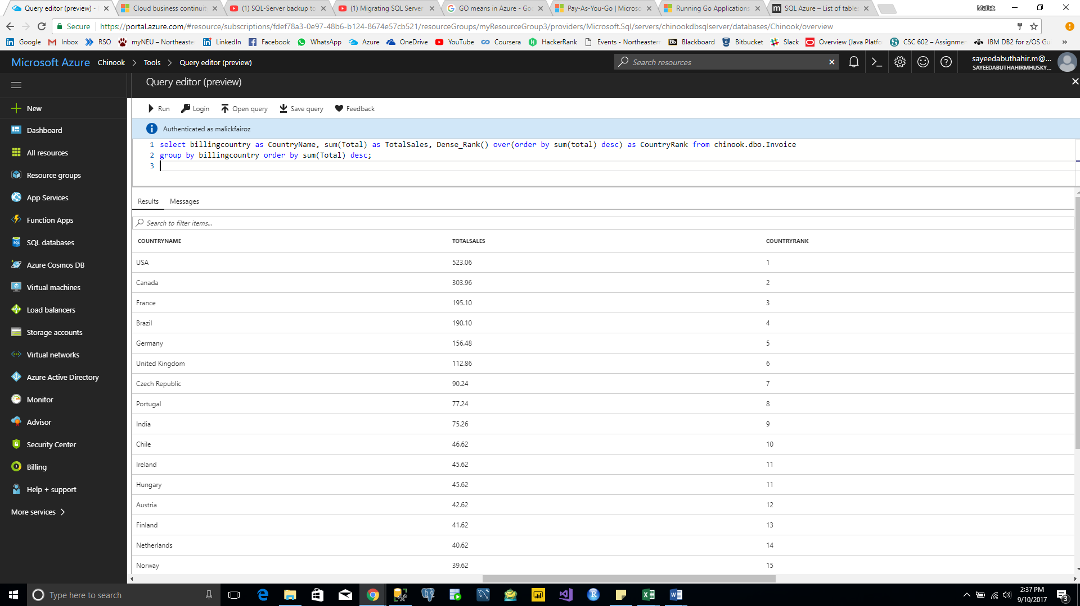

**Query 3:**

select billingcountry as Country, billingstate as State, billingcity as City, sum(Total) as TotalSales from chinook.dbo.Invoice group by billingcountry,billingstate,billingcity order by sum(Total) desc;

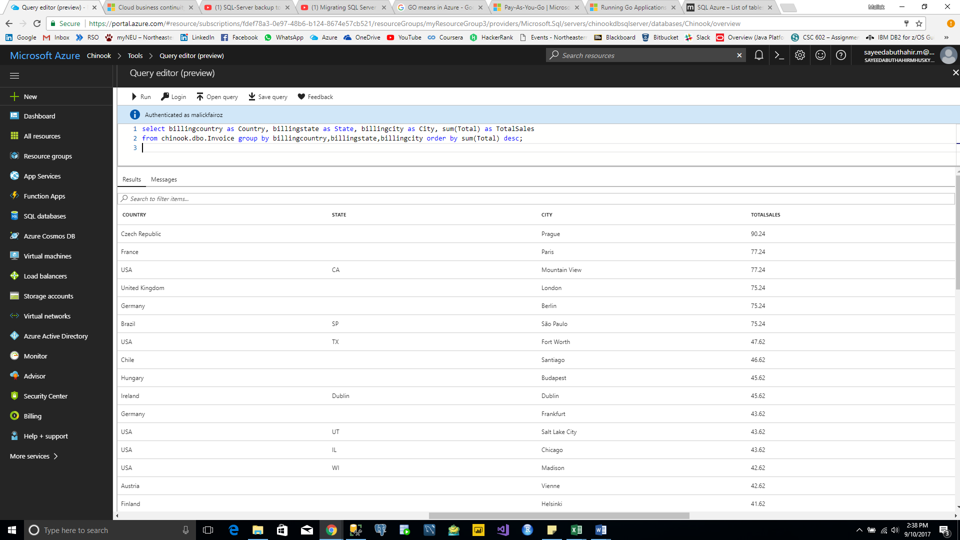

**Query 4:**

select concat(cus.firstname + ' ', cus.lastname) as CustomerName, sum(inv.Total) as TotalSales, DENSE_RANK() over (order by sum(Total) desc) as CustomerRank

from chinook.dbo.Invoice inv inner join Chinook.dbo.Customer cus on inv.CustomerId=cus.CustomerId group by concat(cus.firstname + ' ', cus.lastname) order by sum(inv.Total) desc;

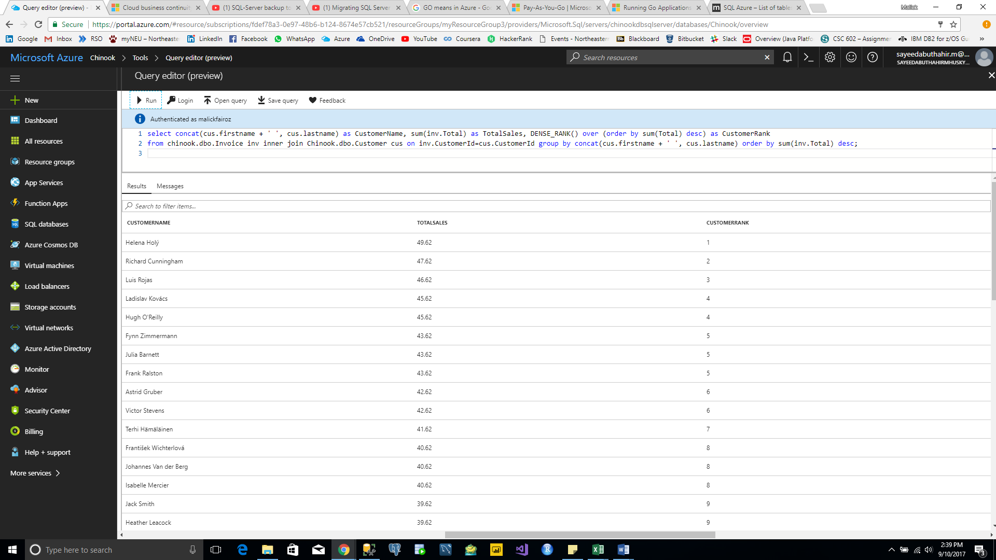

**Query 5:**

select ar.name as ArtistName, sum(iv.Total) as TotalSales, DENSE_RANK() over(order by sum(iv.total) desc) as ArtistRank from dbo.Invoice iv inner join dbo.InvoiceLine il on iv.InvoiceId=il.InvoiceId inner join dbo.Track tr on il.TrackId=tr.TrackId inner join dbo.Album al on tr.AlbumId=al.AlbumId inner join dbo.Artist ar on al.ArtistId=ar.ArtistId group by ar.name order by sum(iv.Total) desc;

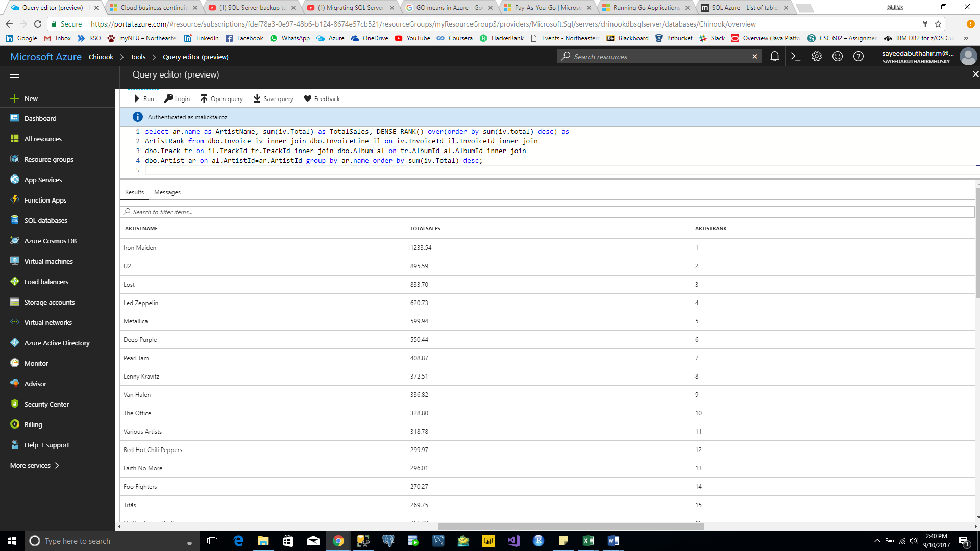

**Query 6:**

select ar.name as ArtistName, al.Title as AlbumName, sum(iv.Total) as TotalSales

from dbo.Invoice iv inner join dbo.InvoiceLine il on iv.InvoiceId=il.InvoiceId inner join

dbo.Track tr on il.TrackId=tr.TrackId inner join dbo.Album al on tr.AlbumId=al.AlbumId inner join dbo.Artist ar on al.ArtistId=ar.ArtistId group by ar.name, al.Title order by sum(iv.Total) desc;

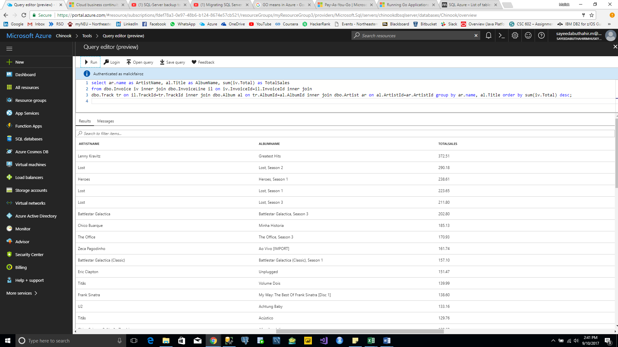

**Query 7:**

select CONCAT (emp.firstname + ' ',emp.lastname) as EmployeeName, sum(inv.Total) as TotalSales from dbo.Invoice inv inner join dbo.Customer cus on inv.CustomerId=cus.CustomerId inner join dbo.Employee emp on cus.SupportRepId=emp.EmployeeId group by CONCAT (emp.firstname + ' ',emp.lastname) order by sum(inv.Total) desc;

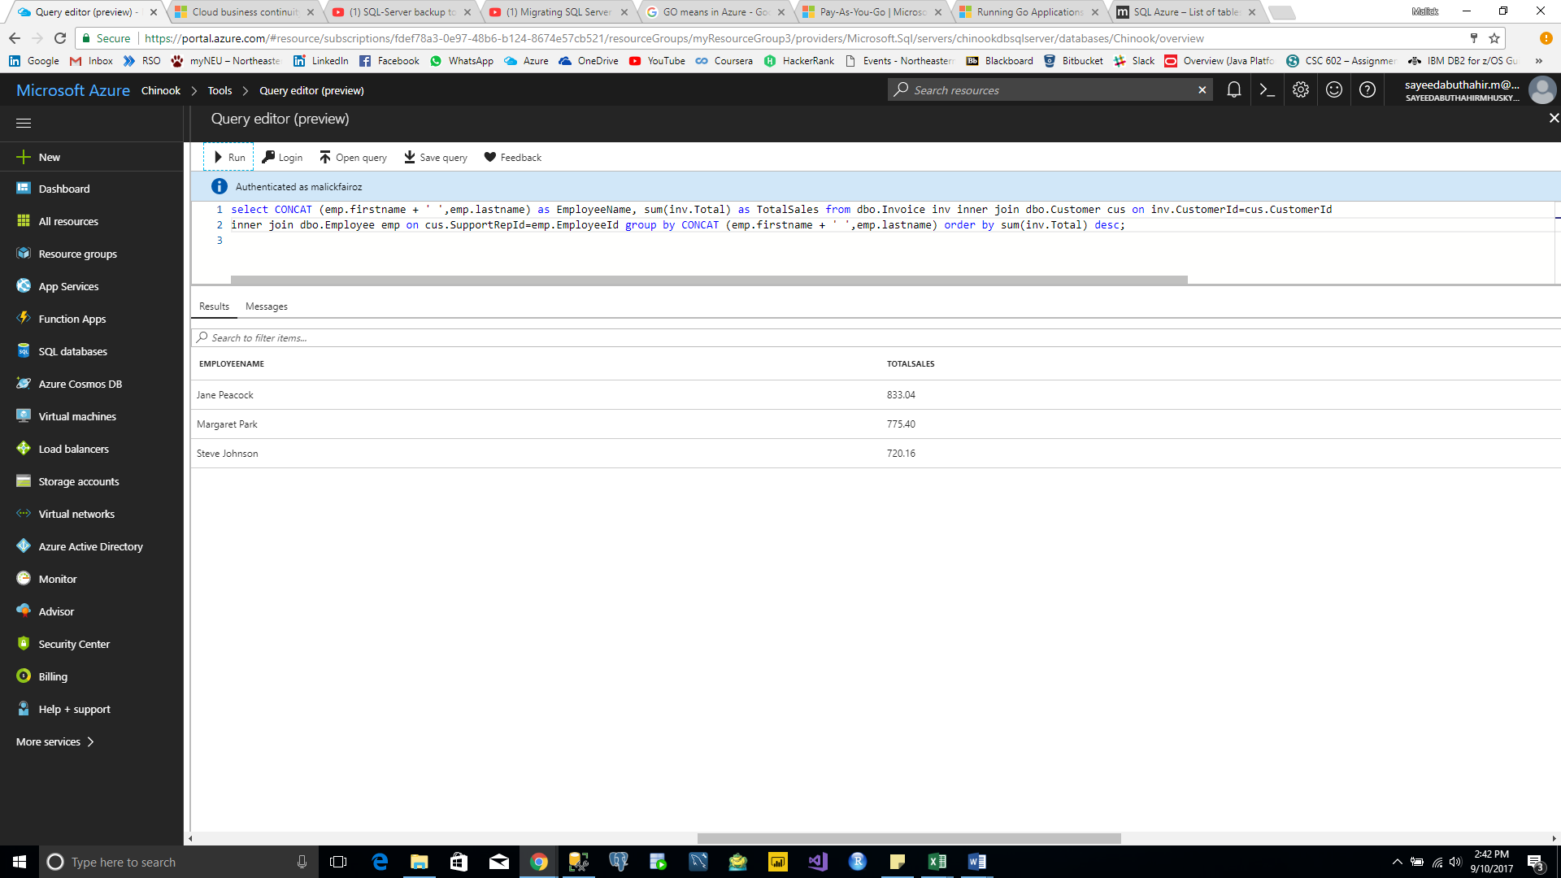

**Query 8:**

select m.name as MediaTypeName, count(t.trackid) as TrackBought, sum(t.UnitPrice) as Cost from dbo.MediaType m inner join dbo.Track t on m.MediaTypeId=t.MediaTypeId group by m.name;

